Software setup:

Fig 1: versions of tools

Data: Found here

QUERY: finalize 20 mins time

With my initial design of these, following the requirement of a mentee via LinkedIn from

Fig 2a: Netedit’s display of the problem domain

Fig 2b: SUMO’s display of the problem domain (standard)

Output

After setting a delay of 500 ms, I ran the program and found the result in Fig 2c, which was shown to the mentee; however, the specific location “maps.app.goo.gl/aJpqKW5gCHSyyuGQ7?g_st=iw”, as shown in Fig 2d.

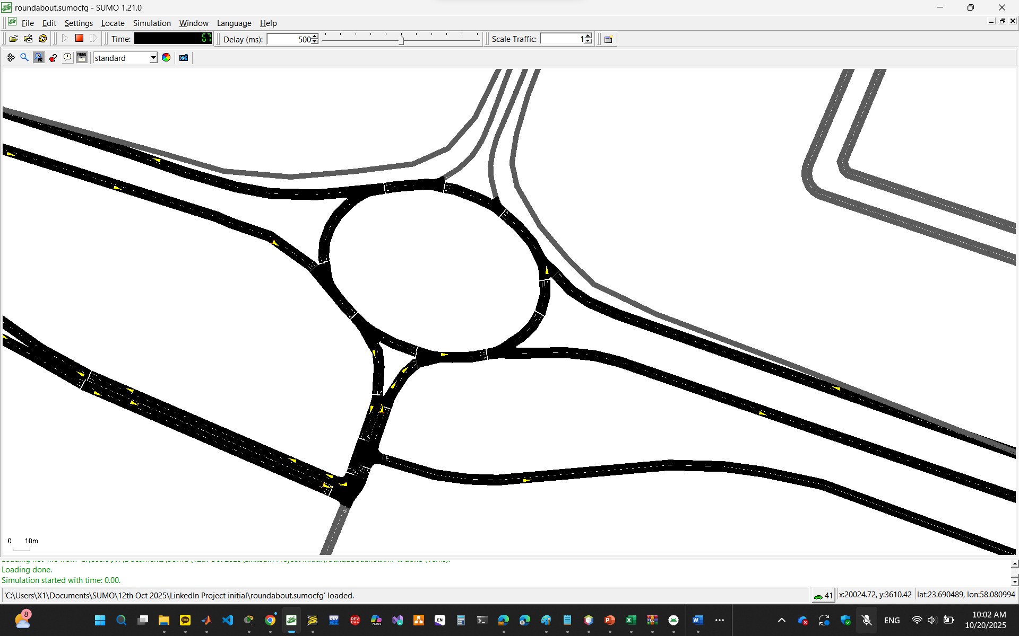

Fig 2c1: Result of simulation at 500 ms (standard)

Fig 2c2: SUMO’s display of the problem domain (real world) at T1

Fig 2c3: SUMO’s display of the problem domain (real world) at T2

Fig 2c4: SUMO’s display of the problem domain (real world) at T3

After showing him Fig. 2c, the mentee later told me the following in our conversation via WhatsApp:

“[09:40, 10/13/2025] Airtel Line (Adversary? STRIDE): First of all thank you Idris

[09:40, 10/13/2025] Airtel Line (Adversary? STRIDE): But something is wrong

[09:40, 10/13/2025] Airtel Line (Adversary? STRIDE): You are welcome.

[09:41, 10/13/2025] Airtel Line (Adversary? STRIDE): What is that ?”

Specifically, the mentee said the following:

“Wait I will draw” and provided the Fig 2d below:

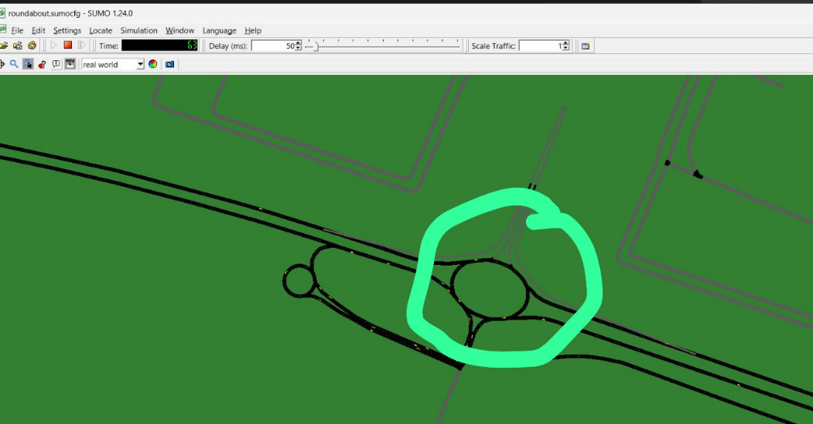

Fig 2d1: Redrawn – scene 1

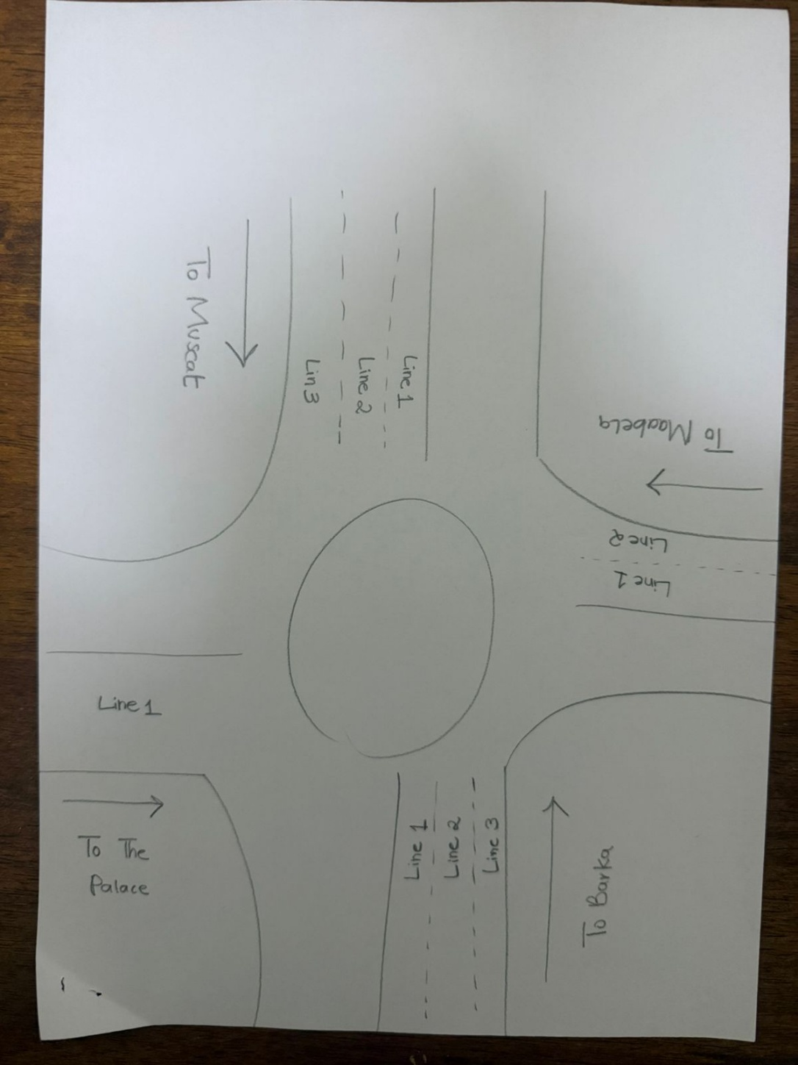

Fig 2d2: Redrawn – scene 2

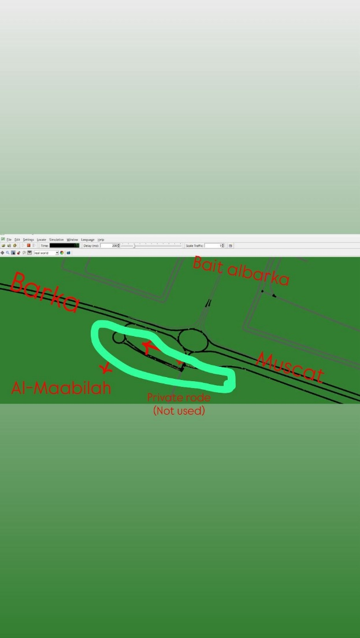

Fig 2d3: Redrawn – scene 3

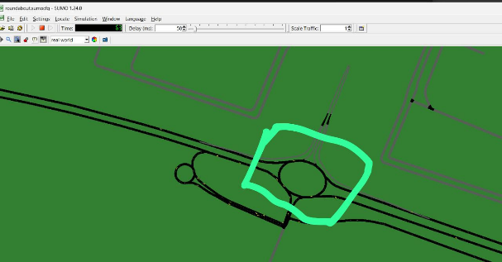

Fig 2d4: Redrawn – scene 4

Fig 2d5: The specific location of the problem domain

Furthermore, I asked about specific details via our next conversation as follows:

“[15:02, 10/13/2025] Idrab: Hi Ghalib,

Thanks again for sharing the sketch. Could you please help clarify a few points so I can align it properly in SUMO?

1️⃣ Please label which road goes to Muscat, Barka, Al Maabilah, and the Palace, and confirm which one is the main entry for most vehicles.

2️⃣ For each direction, how many lanes should I model, and roughly what percentage of vehicles go straight, left, or right?

3️⃣ Should we simulate the traffic as a continuous flow, or in time-based bursts (e.g., morning rush for 15 minutes)?

4️⃣ Can you assign short names for each road arm (like E_Muscat, E_Barka, etc.) so I can map them to the SUMO edges?

5️⃣ Finally, should we include emergency or VIP vehicles from the palace road, or just model regular traffic for now?

[15:27, 10/13/2025] Airtel Line (Adversary? STRIDE): 2- To Barka 3 lines

To Muscat 3 lines

To Mabella 2 lines

To the palace 1 line

Vehicles + bus + track + RV

[15:27, 10/13/2025] Airtel Line (Adversary? STRIDE): 3- continues

[15:27, 10/13/2025] Airtel Line (Adversary? STRIDE): 4- Barka

Muscat

Maabilah

The Palace

[15:27, 10/13/2025] Airtel Line (Adversary? STRIDE): 5- no need

[15:36, 10/13/2025] Airtel Line (Adversary? STRIDE): 1- we just need the approach of the cars - bus -truck -rv from the roundabout only

And everyone where is going in which direction

[15:36, 10/13/2025] Airtel Line (Adversary? STRIDE): Or for every 15 min

Its okay”

I have been on those updates before getting the following result:

Fig 2d6: Updated Result of simulation at 500 ms (standard)

Question:

How do I run the network to satisfy the requirements posted earlier?

Here is the rou.xml file and that of roundabout.sumocfg, being shown: